ECA0901 – DIGITAL SIGNAL PROCESSING

C01 – AT3 SIMULATION EXPERIMENT – 1

1.Design, Realization and Performance Analysis of Butterworth IIR Low-Pass and High-Pass Digital Filters Using MATLAB.
OUTPUT:
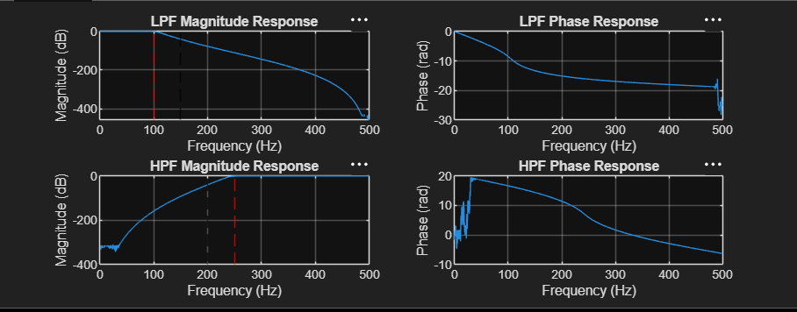

OUTPUT PARAMETERS:
